AI-Based Electrical Fire Prevention System Using IoT Sensors and Machine Learning

Surabhi Kerketta
Department of CSE (AI and ML) VISTAS, Chennai, India surabhikerketta29@gnail.com
Vagitha Rifana
Department of CSE (AI and ML) VISTAS, Chennai, India vagithaliyaquthali@gmail.com
Rithika G
Department of CSE (AI and ML) VISTAS, Chennai, India rithuganesh03@gmail.com
Dr. G.Revathy,
Assistant Professor,
Department of AI&ML
revathy.se@vistas.ac.in

Abstract— Electrical fires are often caused by electrical and environmental conditions and are not detected until the smoke and flames of the fire start. To address this issue, we have created a prototype that monitors the temperature, voltage, current and smoke of an electrical device using the ESP32 IoT platform. An machine learning model classifies the risk of the situation into four levels of risk safe,warning,high risk or critical.We created a data set of 6,400 samples to train the machine learning model. The random forest model that was trained with the data set achieved an accuracy of 99.06%. However, for the embedded device that we created, a decision tree model was used which achieved an accuracy of 98.12%. When the system detects a state that indicates a potential fire, it will trigger a relay switch that cuts the power to the electrical device. In addition, a buzzer will sound and an SMS message will be sent to a designated phone number via the SIM800L GSM module. All sensor readings and events that occur are also logged. We tested our prototype in a controlled environment. This is a student prototype and is not intended to be used for high current applications.

Keywords— fire prevention, ESP32, Internet of Things, machine learning, Decision Tree, Random Forest, multi-sensor monitoring GSM alert

I. INTRODUCTION

Electrical fires are a serious safety issue because many of the electrical system problems that can cause fires are not visible. Many electrical fire alarm systems are only designed to detect smoke or heat after a fire has already begun to develop, whereas a preventive electrical fire alarm system is designed to prevent the fire from ever starting in the first place. A preventive system works by collecting information on parameters, in order to identify patterns of abnormal sensor values, which signifies an approaching threat. The innovative system relies on sensing and machine learning, since it allows the system to provide a multi-level classification of electrical-fire threat. An ESP32 development board collects temperature, voltage, current and smoke. The information from the sensors are processed by a pre-trained classifier, which declares one of the four possible class states: Safe, Warning, High Risk, Critical. After declaring Critical state, the system takes actions, using relay to cut off the power. If the classifier finds that the condition is found as critical, then the system attempts to switch a relay to switch off the power, switch on a buzzer and send a GSM SMS message. All of the events will be saved for viewing later. This is a demonstration student-controlled version.The model and prototype are not connected to the high-current circuits of the home or workplace.The difference is important because the model and prototype show that the system is a demonstration prototype and not a certified safety device.
One of the issues as revealed from the earlier studies is that electrical faults such as overheat, over current and high voltage may generate without any smoke and fire..As fire alarms traditionally rely on detecting smoke, heat, and flame once the fire has started, this provides very little opportunity for preventive actions. What is more, traditional fire alarm systems may be operating based on single threshold values or even focused on fire alone. This is why there is a necessity for Development of a real-time system that will be monitoring multiple electrical and environmental parameters, will recognize abnormalities at an early stage and will take appropriate precautionary actions. The main contribution of this project work is mentioned as follows:

- To create an online electrical fire detection system using ESP32 and temperature, voltage, current, and smoke sensors.
- To develop the Random Forest Machine Learning algorithm to determine the presence of any abnormal conditions which could possibly cause electrical fires.
- To classify the level of fire risk into four categories: Safe, Warning, High Risk, and Critical.
- To disconnect the power supply automatically via relay and switch on the buzzer if Critical condition arises.

- To receive SMS alerts through the SIM800L GSM Module without internet or Wi-Fi.
- To record the sensor values, level of risk and other system data for further monitoring and analysis.
- To create an inexpensive, scalable and effective electrical fire detection system suitable for residential, office, laboratory and industrial environment.

II . LITERATURE SURVEY

Recent studies have explored the use of sensors, machine learning, IoT communication, and automatic control for early fire detection and electrical fire prevention. Mbale and Simbeye designed an innovative fire prevention safety system that employs Internet of Things-enabled sensors and automates decision-making procedures for intervention [1]. The authors provided evidence on the potential of fire prevention safety through the use of the automation features of the sensors to detect hazards, evaluate risk levels, issue alerts, and implement prevention measures; however, the system needs more field tests in actual settings, especially in relation to electrical fire activities.

Ma, Xu, and Han [2] proposed an intelligent electrical fire monitoring system based on the EC-IoT for high-rise residential buildings. The system combined monitoring the electrical parameters, arc detection, smart circuit breakers, and the digital simulation of the building to give an early indication of an electrical fire. However, combining these different types of data and digital simulation was difficult to achieve in their system..

Xu, Chan, and Leong [3] examined the effectiveness of artificial-intelligence-based facility systems for the maintenance of building fire safety. Their paper considered the supervision, maintenance, operation of fire-fighting facilities, and staff training. However, the evaluation was focused on building-facility management, and it did not provide continuous sensor-based electrical hazard classification.

Bayegizova et al. [4] applied deep-learning techniques to fire detection from image-based methods. This demonstrated that visual-based detection is a viable deep-learning method of detecting fire conditions visually, but image-based detection can involve intensive processing and may not directly detect electrical parameters, such as high current, high voltage or cable temperature

Khan et al. [5] Have proposed an ESP32-based intelligent fire detection system with machine learning and computer vision for improving safety. The comprehensive research shows the viability of an ESP32 for intelligent fire-monitoring systems. Meanwhile, the integration of multiple electrical and environmental parameters with different degrees of electrical fire risk and automatic protection actions needs further work.

Elhanashi et al. [6] discussed deep-learning techniques, data sets and
challenges for early fire and smoke detection. The review highlighted
the need for the process of data availability, precise detection models,
Computational efficiency, and real world validation. These challenges
point to need for lightweight and easy to carry fire monitoring
Embedded platforms such as systems.

Mastanamma et al. [7] have introduced a fire alarm system using multi-sensor and IoT.Detection and automatic suppression system, electrical isolation.Their work showed the possibility of using multiple sensors in conjunction with Automated protection features to identify and react to fire.Although further development is needed to integrate machinelearning into the system, it is still considered a worthwhile next step.It is a multi-level electrical risk classification embedded based.monitoring.

Emmanuel et al. [8] presented research on intelligent fire detection system based on deep learning and multi-sensor data fusion. In their work they demonstrated that the fusion of data from different sensors improves fire information. The detection reliability is higher for multiple sensing than for single sensing parametric.But there are complexities and implementation issues. The deployment problem still is quite challenging.

S. He, J. [9] analyzed the temperature forecasting and alerting of
Use a mathematical model to resistively model an electrical circuit fire. Their the research by work has shown that the early detection of temperature behaviour is suitable for.Forecast of electrical fire situations.However, relying mainly on temperature-based modelling may not provide sufficient information when several electrical and environmental parameters change simultaneously.

S. He, X. [10] proposed an electrical fire risk prediction and early-warning method based on fire-fighting big data. Their study showed the capability of data-driven approaches in predicting electrical fire risks. But big-data based approaches might need Extensive datasets and computational infrastructure, which can be extremely demanding and require a significant amount of time.Implementing directly in small embedded devices is difficult.

Li et al. [11] developed an IoT-based fire monitoring and control system. The study demonstrated how IoT technologies can be used to monitor fire-related conditions and support control actions. However, the work does not specifically focus on machine-learning-based classification of multiple electrical fire-risk levels on a compact embedded platform.

Dai et al. [12] proposed an electrical fire monitoring IoT framework using edge computing for ancient architectural complexes The look at highlighted the significance of local data processing and IoT-based electrical fire monitoring. However, the system was designed for a larger architectural environment and does not specifically address a low-cost embedded prototype combining electrical and environmental sensing with automatic protection.
Gaur et al. [13] presented an artificial-intelligence and multi-sensor-fusion-based universal fire detection system for smart buildings using IoT techniques. Their work demonstrated the benefits of combining multiple sensor inputs with AI for improved fire detection. Nevertheless, the computational requirements and implementation complexity of multi-sensor AI systems can be challenging for resource-constrained embedded platforms.

Wang et al. [14] developed a gas detection system combined with a Global Extension Extreme Learning Machine for early warning of electrical fires. A prototype they made depicted how electrical-fire warning using parameters and machine learning for gas-related Electrical-fire warning using parameters and machine learning. But perhaps gas sensing alone might not be enough. Electrical hazards is a kind of electrical hazards caused by abnormal current: for instance, temperature and some environmental parameters.

The model proposed by Ko et al. [15] was studied to evaluate an electrical fire prediction model.machine learning. Their findings were that machine-learning.These techniques can be used for predicting electrical fires. However,additional real-time multi-sensor monitoring,
Such automatic safety actions can increase the benefit of such systems.

III. METHODOLOGY

The proposed system uses an ESP32-based architecture. It integrates sensors and a machine-learning model for electrical fire-risk classification. The methodology consists of steps: sensor data acquisition, data preprocessing, dataset creation, model development, embedded deployment, risk classification and automated response.
The Work Flow Frame work is depicted below Figure.1

  - Sensor Data Acquisition

The system uses an ESP32 DevKit as the microcontroller. Four parameters are monitored all the time: Temperature measured by a DSB1820 sensor Current measured by an ACS712 sensor Voltage measured by an AC voltage sensor module, Smoke or gas level measured by an MQ-2 sensor. The sensors connect to ESP32 through GPIO and ADC interfaces. The collected values create a four-feature input vector: X = [Temperature, Voltage, Current, Smoke]. ESP32 reads these parameters continuously. Supplies the input needed for risk classification.

  - Dataset Generation and Preprocessing

Because gathering real critical electrical-fault conditions on live hardware would be unsafe and impractical a synthetic dataset was created with generate_dataset.py. The dataset holds 6,400 samples split into four risk classes: Safe – 1,500 samples, Warning – 1,500 samples, High Risk – 1,506 samples, 1,894 samples. For each risk class realistic ranges of temperature, voltage, current and smoke were defined. Gaussian noise was added to mimic sensor variation. Borderline samples were also created using weighted multi-feature scoring so that the model could learn transitions between risk levels instead of relying solely on hard thresholds. The dataset was split in an 80:20 ratio with 1,280 samples reserved for testing.

  - Machine-Learning Model Development

The preprocessed sensor dataset trained machine-learning classifiers for four-class risk prediction. During development a Random Forest

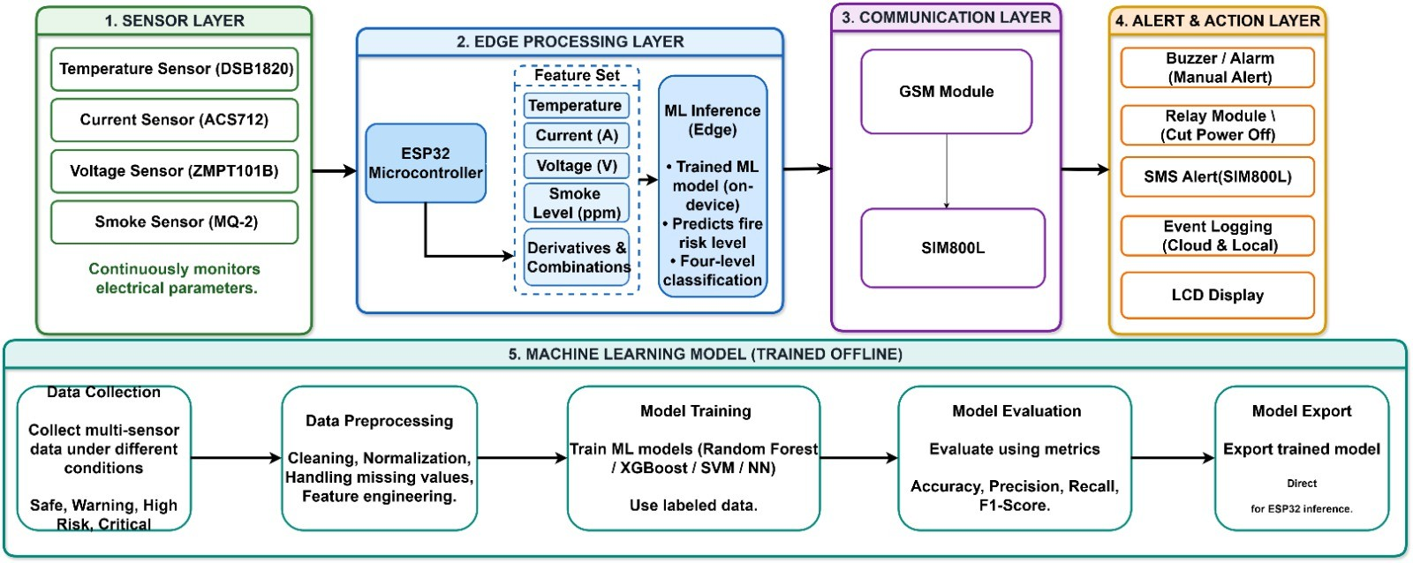

Figure 1.Frame for fire prevention using IOT device

with 150 trees and a maximum depth of 10 was evaluated. The Random Forest reached 99.06% accuracy on the held-out test set. For deployment on ESP32, ﻿a Decision Tree with intensity of 6 was chosen because its small and simple structure fits an embedded system better. The trained Decision Tree was converted into code with micromlgen.

  - Risk Classification

The deployed Decision Tree takes the four sensor parameters as input and classifies the current condition into one of four risk levels: Safe Warning, High Risk, Critical. Classification depends on the combined pattern of temperature, voltage, current and smoke not a single sensor value. The deployed Decision Tree achieved 98.12% accuracy on the 1,280-sample test set.

  - Automated Response

When the predicted risk level is Critical ESP32 starts these actions: The relay disconnects the prototype load and power path. The buzzer sounds. An SMS alert is sent via the SIM800L GSM module. The event and its sensor readings are logged. A cooldown mechanism prevents repeated SMS alerts while the Critical condition persists. For Safe Warning and High Risk monitoring. Sensor readings and classifications are recorded.

  - Prototype Validation

The whole system was. Tested as a controlled student prototype. Live ESP32 sensor readings verified the behavior of sensing, classification, relay, buzzer, GSM and logging. The prototype did not connect to real high-current household or electrical circuits. Thus the reported machine-learning accuracy reflects performance, on the synthetic test dataset while hardware testing shows prototype-level operation.
.

IV. DATASET AND MODEL DEVELOPMENT

Because making real Critical-risk electrical fault situations on real hardware would be unsafe and hard a made-up dataset was created by code using generate_dataset.py for training and testing the model. Real ESP32 sensor data were used separately to check how the prototype works on the board.
The data set has 6,400 entries with four numbers: temperature in °C voltage in V current in A and smoke level from the MQ-2 sensor. The classes are 1,500 Safe, 1,500 Warning, 1,506 High Risk and 1,894 Critical. Realistic limits were set for each class and random noise was added. Also 400 edge cases were made using a weighted mix of this is because features were given to the classifier to learn the matrix of borders rather than fixed cuts.

The data was split into 80% for training. 20% For testing keeping the class mix the same with a fixed seed of 42 giving 1,280 test entries. A Random Forest with 150 trees and depth 10 was checked offline. A Decision Tree with depth 6 was chosen later for the embedded board because it is easier for a microcontroller. The Decision Tree was saved for ESP32 use with micromlgen.

V. SYSTEM PROTOTYPE AND IMPLEMENTATION

The prototype uses an ESP32 DevKit as the brain. A DSB1820 temperature sensor plugs into pin 4 the ACS712 current sensor into pin 34 the AC voltage sensor into pin 35 and the MQ-2 smoke sensor into pin 32. A relay on pin 26 cuts the power for the prototype while a buzzer on pin 27 makes a warning. A 16×2 I2C LCD uses pin 21 for SDA and pin 22 for SCL. The SIM800L GSM module talks to the ESP32 over its lines using pins 16 and 17.

While running the ESP32 keeps taking the four sensor numbers. Makes a feature list. The embedded Decision Tree sorts the situation into Safe, Warning, High Risk or Critical. When the situation is Critical the relay turns off the prototype load, the buzzer. An SMS goes out via the SIM800L. A pause timer stops SMS in a row and the sensor values, decisions and actions are saved in the log.

So the system goes through steps: get sensor data → clean it → machine-learning decision → risk level choice → log the event and react automatically. The prototype was tried in a lab not on big household or factory electrical lines.

EXPERIMENTAL RESULTS

The Random Forest got 99.06% correct on the test data. The Decision Tree chosen for the embedded board got 98.12% on the same 1,280

test entries. The Decision Tree numbers are the ones because that model runs on the ESP32 prototype.

For each class the precision, recall and F1 are 1.00/1.00/1.00 for Safe, 0.99/1.00/1.00 for Warning, 0.95/0.99/0.97 for High Risk and 0.99/0.95/0.97 for Critical. The hardest part to tell apart was, between Critical and High Risk. The classification performance is represented by the Confusion Matrix in Figure.2

The results show that the classifier learned the generated multi-sensor patterns effectively. However these numbers describe performance on a synthetic test dataset. Should not be taken as a real probability of preventing actual electrical fires The Pre-Class precision Values for the four risk classes are presented in Figure.4 .
electrical sensor data, wider hardware conditions and certified electrical protection hardware would be needed before any practical

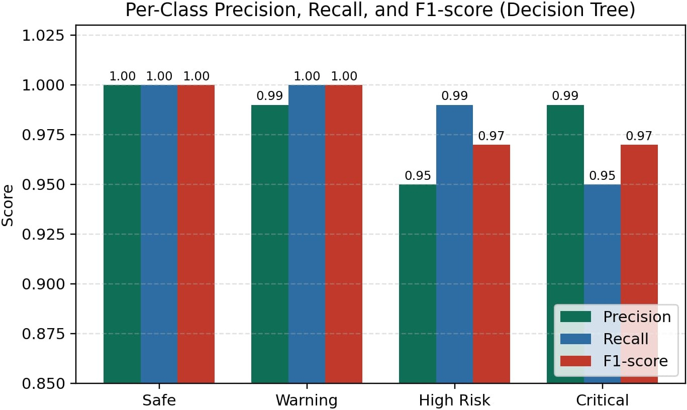

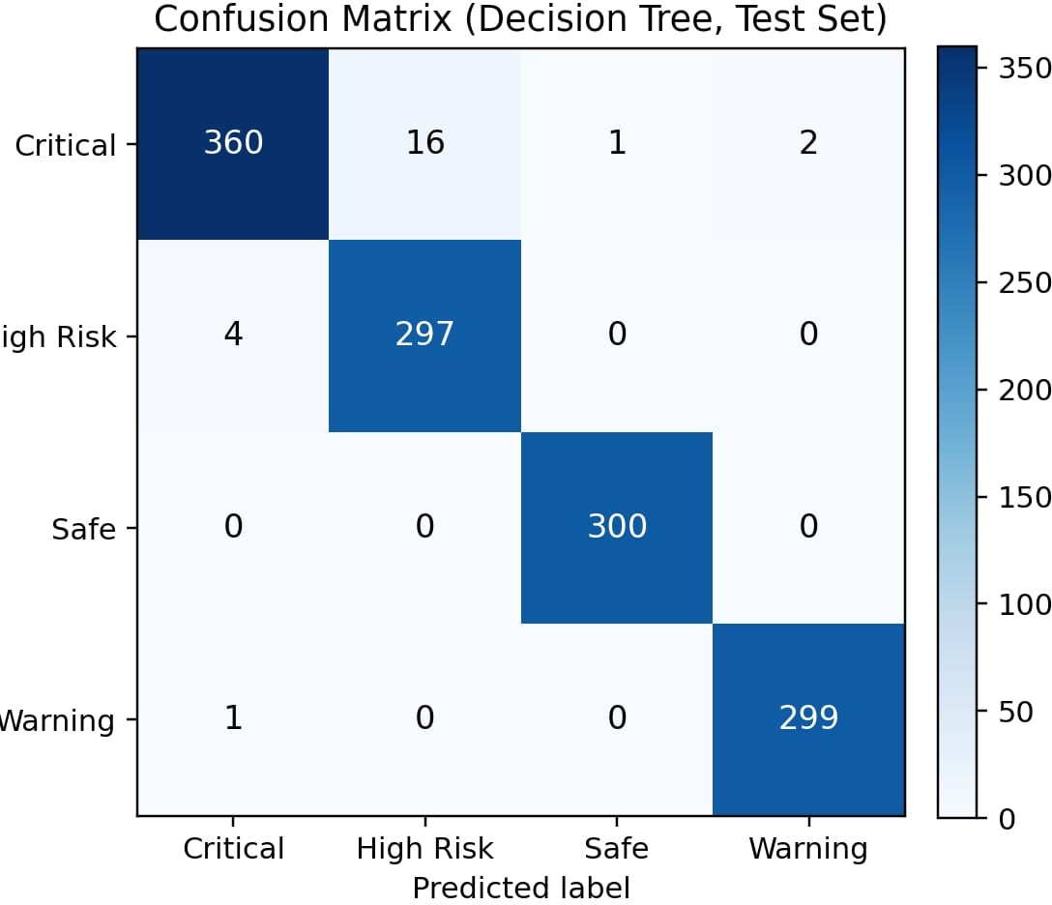
Figure.4 Pre-Class Precision

deployment.

VII. OVERALL LIMITATION

Figure2. Confusion Matrix

The confusion matrix shows that 360 Critical samples were classified correctly. Of these 16 were called High Risk 1 was called Safe. 2 Were called Warning. The High Risk group has 297 predictions and 4 Critical predictions. The Safe group has 300 predictions. The Warning group has 299 predictions and one Critical prediction.The Class Distribution of the data set is presented in Figure.3
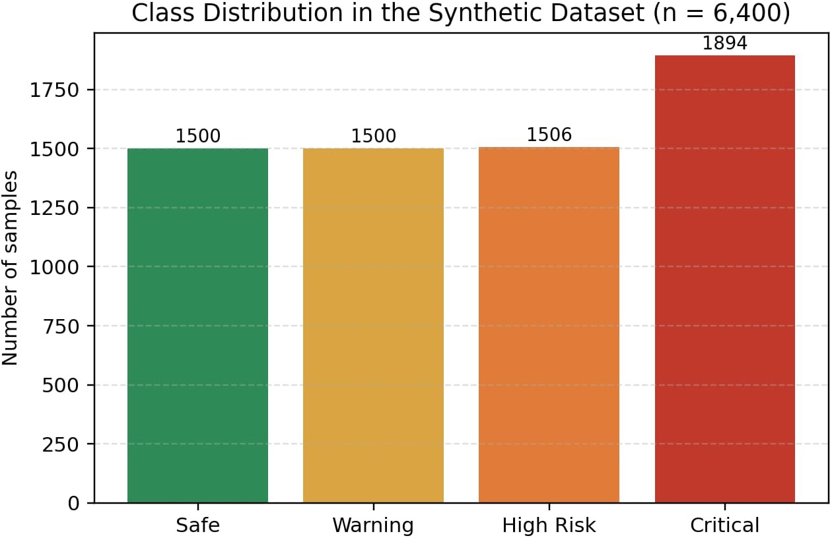

Figure3.Class Distribution
The completed prototype showed the end-to-end operation: ESP32-based sensing, four-level risk classification, critical-condition relay action, buzzer activation, GSM SMS notification and event logging. This prototype therefore shows how machine learning can be combined with sensing and automated response in a small device.

Indeed, it has its limitations. The set of data used for training was synthetic but based on realistic operating range of the device. It has been tested on a physical prototype under controlled conditions, and is not suitable for high-power household and industrial power supplies. The Decision Tree is shallow enough to be embedded into an embedded environment, but it would need extensive testing and validation on electrical sensors, extended hardware testing and electrical protection hardware certification to be applied in practice.

VIII. CONCLUSION

A prototype using an ESP32 with a combination of sensor technology and machine learning as part of an artificial intelligence (AI) powered electrical fire detection system has been designed and built. Temperature, voltage, current and smoke levels were used as features to differentiate states into safe, warning, high risk and critical. A random forest classifier obtained an accuracy of 99.06% when tested on the same evaluation set that was used to test the lightweight decision tree that will be implemented on an embedded platform. The results demonstrate how this prototype can operate automatically through isolation of relays, activation of buzzers, sending messages via GSM/SMS, and logging events. The first stage in the development of the prototype for proactive electrical-risk monitoring has been completed. The evaluation of the synthetic data model and the verification of the hardware prototype in an experimental setting have been decoupled, as the former had already been performed as part of the research. The experts suggest that further research should be devoted to obtaining extensive empirical data in test settings. The opportunity to subject the electrical hazard monitoring system to more practical trials should be given to enhance the reliability of the electrical hazard monitoring system. Most experts are convinced that certification of the electrical safety of the electrical-risk monitoring system will be mandatory, as the adequacy of protective systems must be formally established

IX.REFERENCES

- J. Mbale and N. Simbeye, "Development of an Intelligent Fire Prevention System Using IoT-Enabled Sensors and Automated Countermeasures," in Proc. 7th Int. Conf. Information and Communication Technologies (ICICT), Lusaka, Zambia, Oct. 15–16, 2025, pp. 416–421.
- M. Ma, C. Xu, and J. Han, "Application of an Intelligent Electrical Fire Monitoring System Based on the EC-IoT Framework in High-Rise Residential Buildings," Syst. Soft Comput., vol. 7, Art. no. 200257, Apr. 2025.
- W. Xu, S. C. Chan, and W. Y. Leong, "Effectiveness Study of Artificial Intelligent Facility System in Maintaining Building Fire Safety," Discrete Dyn. Nat. Soc., vol. 2023, Art. no. 2592322, 2023.
- A. Bayegizova et al., "Fire Detection Using Deep Learning Methods," Int. J. Electr. Comput. Eng. (IJECE), vol. 14, no. 1, pp. 547–555, 2024.
- M. Khan et al., "ESP32-Based Intelligent Fire Detection System Utilizing Machine Learning and Computer Vision for Enhanced Safety in Indian Micro and Small Enterprises," 2026.
- A. Elhanashi et al., "Early Fire and Smoke Detection Using Deep Learning: A Comprehensive Review of Models, Datasets, and Challenges," Appl. Sci., vol. 15, Art. no. 10255, 2025.
- Y. Mastanamma et al., "IoT-Based Multi-Sensor Fire Detection and Automated Suppression System with Electrical Isolation," Int. J. Res. Appl. Sci. Eng. Technol. (IJRASET), vol. 14, no. 4, pp. 2337–2343, 2026.
- G. P. Emmanuel, J. D. Jiya, Y. H. Shuaibu, J. T. Abraham, R. Ogwu, and L. E. Bitrus, "Intelligent Fire Detection Systems Using Deep Learning and Multi-Sensor Data Fusion: A Comprehensive Review," Int. J. Sci. Res. Eng. Dev. (IJSRED), vol. 8, no. 5, pp. 2346–2357, Sep.–Oct. 2025.
- S. He, J. Guan, J. Wang et al., "Study on Temperature Prediction and Early Warning of Building Resistive Electrical Circuit Fire: A Mathematics Model," 2025.
- S. He, X. Shu, J. Hu, L. Zhang, J. Zhang, J. Zhang, and Y. Zhou, "Prediction and Early-Warning Method of Electrical Fire Risk Based on Fire-Fighting Big Data," J. Tsinghua Univ. (Sci. Technol.), vol. 64, no. 3, pp. 478–491, 2024.
- Y. Li, J. Yi, X. Zhu, Z. Wang, and F. Xu, "Developing a Fire Monitoring and Control System Based on IoT," Adv. Intell. Syst. Res., pp. 174–178, 2016.
- H. Dai, P. Shi, H. Liu, R. Chen, and Z. Chen, "Electrical Fire Monitoring IoT Framework for Ancient Architectural Complex Leveraging Edge Computing," Int. J. Commun. Syst., vol. 35, no. 17, Art. no. e5329, 2022.
- A. Gaur, A. Singh, A. Verma, and A. Kumar, "Artificial Intelligence and Multi-Sensor Fusion Based Universal Fire Detection System for Smart Buildings Using IoT Techniques," IETE J. Res., vol. 69, no. 12, pp. 9204–9216, 2023.
- Y. Wang, Q. Li, J. Zhang, C. Yin, Q. Zhang, Y. Shi, and H. Men, "A Gas Detection System Combined with a Global Extension Extreme Learning Machine for Early Warning of Electrical Fires," Sens. Actuators B: Chem., vol. 423, Art. no. 136801, 2025.
[15] K. Ko, D. Hwang, S.-J. Park, and G.-G. Moon, "Electrical Fire Prediction Model Study Using Machine Learning," J. Korea Inst. Inf. Electron. Commun. Technol., vol. 11, no. 6, pp. 703–710, 2018.

